Scientific/Historical Travelling
A Self-Designed Tour of England, Scotland, France, Switzerland, and Germany
As Part of a Sabbatical Leave from Allegheny College, Meadville, PA
Glen and Kitty Rodgers
March 9 to May 4, 1998
In the spring of 1998, Dr. and Mrs. Rodgers travelled to England, Scotland, France, Switzerland, and Germany to see many sites related to the history of chemistry and physics. In London, they visited the National Portrait Gallery, the Royal Observatory and the Flamsteed House at Greenwich, University College London (hosted by Chris Cooksey), the Faraday Museum at the Royal Institution, the Science Museum (hosted Peter Morris). At Cambridge University (hosted by Peter Wother) they visited the "Old Cavendish" including the Whipple Museum, the crocodile carving in honor of Ernest Rutherford, and the Maxwell Lecture Hall. They also visited the Eagle Tavern where Watson and Crick celebrated their discovery of the helical structure of DNA and the "New Cavendish" physics laboratory which houses a small but poignant collection of the original equipment devised and employed by the early Cavendish professors of physics including Thomson, Wilson, Aston, and Rutherford.
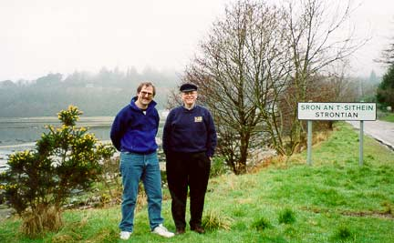

Dr. Rodgers with Dr. John Reglinski (Professor of Chemistry, The University of Strathclyde, Glasgow) at the sign welcoming visitors to Strontian, Argyllshire in the Inner Hebrides, Scotland. Strontian gave its name to the element Strontium that was first discovered by analyzing an ore taken from this area.
In Scotland (hosted by John Reglinski) they visited Iona (where St. Columba first brought Christianity over from Ireland and established a monastery in 563) and Strontian (the town after which the element was named), the Camera Obscura and the Early Technology Shop on the Royal Mile, the Royal Museum of Scotland including the Early Instruments section, and the birthplace of James Clerk Maxwell on India St. (all in Edinburgh). In Glasgow, they visited the University of Strathclyde near George Square. In the University of Glasgow area, they walked beside the River Kelvin, saw statues of Lord Kelvin and Joseph Lister, visited the Hunterian Museum and the Kelvin Hall of physics and astronomy with its "common room" where there are four cases of original Kelvin equipment.
Driving south, they stopped at the Wanlockhead Lead Mining Museum and then visited several sites related to James Clerk Maxwell including Glenlair (the now deserted Maxwell homestead), a small church in Corsair housing an impressive stained glass window installed in Maxwell's honor, and the Parton Kirk where he is buried. Now in England they visited Hadrian's Wall, the birthplace of John Dalton at Cockermouth, Pardshaw Hall where a memorial to Dalton has been placed in the graveyard of the old Quaker Meeting Hall there. In Manchester, they visited the Town Hall with its statues of Dalton and James Prescott Joule and the impressive Ford Madox Brown mural upstairs in the Great Hall showing Dalton collecting marsh gas. They also joined the John Rylands Library and viewed original Dalton manuscripts including the opening pages of his "Lectures in Chemistry, 1827." Continuing down to Manchester Metropolitan University they saw another magnificent statue of Dalton. At the University of Manchester they visited the old Schuster physics building where they stood in the rooms where Rutherford performed the first transmutation of elements and the new Schuster laboratory with its wonderful photographs and theatres named after Rutherford, Moseley, William Bragg, and P.M.S. Blackett. They also drove to the Catalyst Museum in Widnes.
In the Bath area they visited the Roman baths, the Royal Crescent, the Herschel Museum, the Great Circle of Avebury, Stonehenge, Woodhenge, and the Bowood House where Joseph Priestley discovered oxygen gas in 1774. Driving south to Cornwall, they visited Tintagel Castle (the supposed birthplace of King Arthur), the Cornish Beam Engine at Pool, the Geevor Tin Mine, and the statue of Humphry Davy in Penzance. Heading north again, they stopped at Salisbury Cathedral (where they took the "Tour of the Roof Areas" and visited the Chapter House with its one of the four oldest copies of the Magna Carta).
In their week in Paris they visited the National Technical Museum (Reserve) (hosted by Christianne Delpy) with its amazing collection of Antoine Lavoisier artefacts, the Passy district with its statue of Benjamin Franklin, the Curie Museum, the Pantheon (with the newly established graves of Pierre and Marie Curie), the Pasteur Museum, and the Concierge where Lavoisier was imprisoned before he was beheaded in the aftermath of the French Revolution, and the grave of Joseph Gay-Lussac in the Cimitiere du Pere Lachaise.

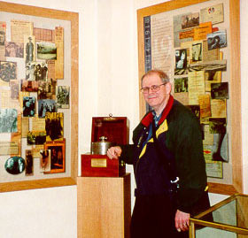

Dr. Rodgers stands beside the lead container used to transport radium. Marie Curie made two tours of the United States (in 1921 and again in 1929). During both of these tours, the women of America donated enough money to buy one gram of radium that was transported in this container.
In Zurich they visited the University of Zurich (hosted by Heinz Berke) to see the Alfred Werner collection of over 2500 coordination compounds and his original polarimeter (see picture below).
In Germany, they saw (1) the statue of Johannes Kepler and small Kepler Museum in Weil der Stadt, (2) the statue of Robert Bunsen, the original house where he and Kirchhoff did their early spectroscopic work, and the exhibits of the Bunsen's original equipment and compounds at the University of Heidelberg, (3) the monument to honor Justus Liebig in Darmstadt (with information provided by Wolfgang Germann), (4) the Liebig Museum (hosted by Magnus Mueller) in Giessen, (5) the two rooms where Wilhelm Rontgen discovered x-rays in 1895 in Wurzburg, (6) the Fraunhofer Glasshutte at Benediktbeuren, and (7) the Deutsches Museum in Munich. They also took a trip to the Berchtesgaden Salt Mines in Austria.

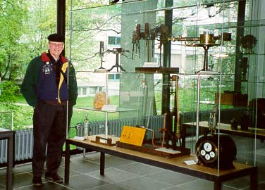

Dr. Rodgers at the small Robert Bunsen display at the University of Heidelberg in Germany. On the top shelf, from left to right, are Bunsen's original burner and several original spectroscopes.
In the Netherlands they visited the Boerhaave Museum in Leiden and the Teyler's Museum in Haarlem.

